
Coaching Safety Guidelines

I. MANDATORY TRAINING - Concussion Training
Coaches are mandated to take Concussion Training, once per year. This training is due before the start of the season. An e-mail was sent to all coaches with instructions and a link to complete this training. Please ensure you either send your certificate to lyaadmin@lyasports.org OR upload it to our concussion certificate form: ConcussionCertificate Form

II. INTERRUPTION/TERMINATION DUE TO WEATHER
Please advise your team parents during questionable weather if they have not been contacted one hour or more before the official start time of the game, they are to show up to play.
The following weather rules have been updated and developed with player, coach, and spectator safety in mind. These regulations are to be strictly followed:
1. If possible, use a mobile app or text alerts to monitor for adverse weather conditions during a practice or game. Under NO circumstances may play be conducted during a thunderstorm. The sooner activities are stopped, and people get to a safe place, the greater the level of safety. Criteria that should be used to halt activities when a storm approaches include:
a. the sky looks threatening; or
b. wind speed is increasing/ becoming constant
c. the time between lightning flash and thunder is 35 seconds or less (in which case a thunderstorm is most likely 7 miles away or less and poses a hazard).
2. At first sign of a thunderstorm, practice/game play is to be halted - players and coaches should clear the field and find safe shelter. After the thunderstorm has passed, wait for a period of 30 minutes before potentially resuming activities. A thunderstorm is considered over when the last audible thunderclap has been heard and/or lightning has stopped. The 30-minute resume play clock starts when either of the aforementioned occur. A joint decision will be made by the coaches and umpire regarding continuation of a game.

3. Practices/games may cease or be cancelled due to high temperatures. It is mandatory play cease or be cancelled if temperatures reach 105 degrees Fahrenheit or above. A joint decision will be made by the coaches and umpire regarding the continuation of a game if temperatures are nearing 105 or players are showing adverse effects due to the heat.
4. The Umpire has the discretion to cease play if the weather, temperatures, or darkness proves a safety risk to the players. In leagues with no umpire, coaches are expected to act responsibly and not cause harm to the players or to the fields.
5. If there is a question or dispute regarding ceasing or cancelling practice/play due to weather conditions, immediately contact the Safety Officer, Jessica Cornell, via text/call as she has final authority regarding these decisions.
III. INJURY REPORTING
In the event of an injury, remove the athlete from play. Call a parent/guardian over if they are present. For minor injuries, use the items in the First Aid Kit to attend to the injury. If you are not sure of the severity of the injury, do not move the player - ask for any available professional healthcare provider, call an ambulance if necessary, get a statement from each coach, and file an Injury Report with the Safety Officer and League Commissioner as soon as possible using the form located on the LYA website. To ensure all injuries are reported, contact the Safety Officer via text/call/e-mail as soon as injury has occurred. The officer will then follow up to ensure an Injury Report is completed.
Key Emergency Contact Information
Medical Emergencies Dial 911 Urgent Care/Emergency Rooms
MedNow Urgent Care  Hours: 8:00 a.m. – 8:00 p.m. | (610) 822-2022  278 Eagleview Blvd, Exton
Main Line Health Urgent Care  Hours: 8:00 a.m. – 9:00 p.m. | 484-565-1293  154 Exton Square Pkwy, Exton
Chester County Hospital -  Emergency Department | 610-431-5550  701 E Marshall St, West Chester
Paoli Hospital -  Emergency Department | 484-565-1043  255 W Lancaster Ave, Paoli

Medical Alert Information
Each Team Safety Coordinator must have Medical Alert (preferably the LYA applications, which include medical alerts) and emergency phone contact information in their possession for all practices and games, along with a copy of this Safety Manual.
- All Coaches and Assistant Coaches are expected to read and familiarize themselves with any Special Medical Conditions identified on the Registration Forms for the players on their team.

Lionville Youth Association See the Resources tab at www.lyasports.org
- LYA Injury Report. This form is to be completed should an injury occur at an LYA sporting event, regardless of the severity of the injury. This form is automatically forwarded to the LYA Executive Board, Sports Commissioner and Safety Officer for review.
o https://docs.google.com/forms/d/e/1FAIpQLSdY8OmQr5Zvun1omshy85rArK31d5cWrP o5AmHvlJZVFR_rgA/viewform?
- LYA Incident Report. This form is to be completed for any safety, security, or other incident occurring at an LYA sporting event. This form is automatically forwarded to the LYA Executive Board, Sports Commissioner and Safety Officer for review, follow up and resolution.
o https://docs.google.com/forms/d/e/1FAIpQLSenDLWmmDtoiiV_hhnlx5RXoAdG8ag d478RJAuw37rkp-dHsg/viewform?
LYA Sports Commissioners
Name | Sport | Email Address
Herb Merritt | Baseball | lyallpresident@gmail.com
Melissa Esposito | Softball | lyasoftballcp@outlook.com
Marty Dunn | Lacrosse | lyaboyslacrosse@gmail.com
Jason Wolensky | Girls’ Lacrosse | wolenskyj@gmail.com
Doug Pusey | Intramural & Travel Soccer | lyasoccer16@gmail.com
Laura Menzel | Field Hockey | LYAfieldhockey@gmail.com
Ashley Pirich | Basketball | lyabasketball1@gmail.com
Jeff Fortmann | Travel Baseball | jeffreyfortmann@gmail.com
Nora Petchkofski | Travel Softball | npetchkofski@gmail.com
Pennsylvania Childline Hotline |  | 1-800-932-0313

IV. AED’s/First Aid Kits
First Aid Kits are kept in the job boxes and/or equipment sheds at fields, as well as the Equipment Room at Foster Field, available for use during practices and games.

- Regularly check the First Aid Kit for completeness. These kits include protective gloves, hand sanitizer, instant cold packs, cotton balls, pain relieving antiseptic cleansing spray, bandages, and gauze. If you use an item from the first aid kit, please contact the safety officer so the kit can be resupplied.
- Instant information for the most common first aid emergencies can also be accessed from the Red Cross First Aid App, available via download from the Apple App Store or Google Play or text "GETFIRST" to 90999.

Automated external defibrillators (AEDs) are available at all parks LYA utilizes, for use by trained coaches and other good Samaritans. Familiarize yourselves with their locations and watch these two short instructional videos.
- Hands-Only CPR:
https://youtu.be/5tx_8LHgxVw?si=gpHQX47sgdHN8C_r
- Using an AED with Hands-Only CPR:
https://youtu.be/a469vE-QiEg?si=QsfiMANTHHDGlFfZ
AED Locations within each park marked by .
Lionville Park
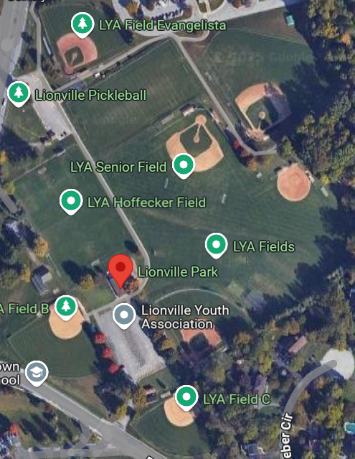
3 AEDs are located within Lionville Park.
1. Main Pavillion, middle pillar, facing out to the parking lot (year round)
2. Shed at Ted Gacomis Senior Park, facing the Lionville Pickleball courts (year round)
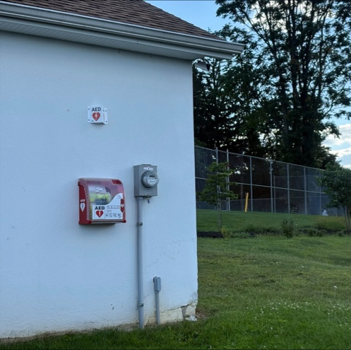
3. Shed at Senior Field, facing the Lionville Middle School Parking Lot (only available March-November)

Target Field
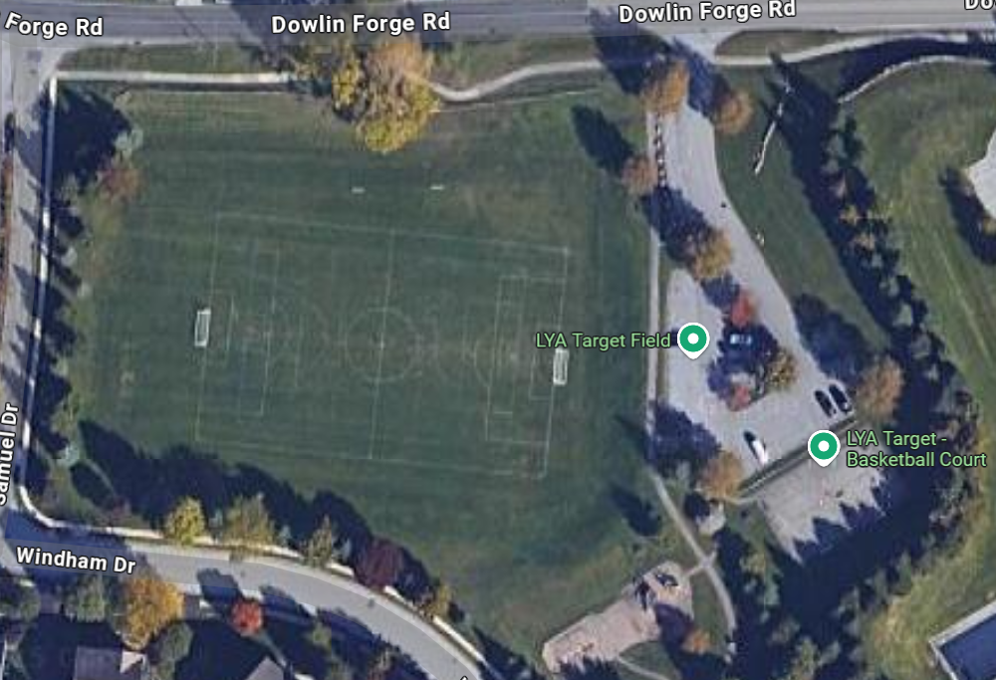
1 AED is located in Target Park (year round) to the right of the driveway as you enter the park, near the bench.
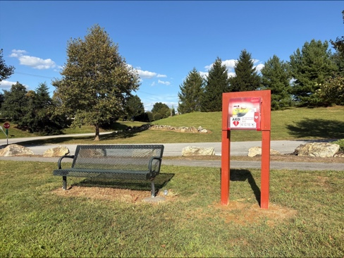

Shamona Peck Field
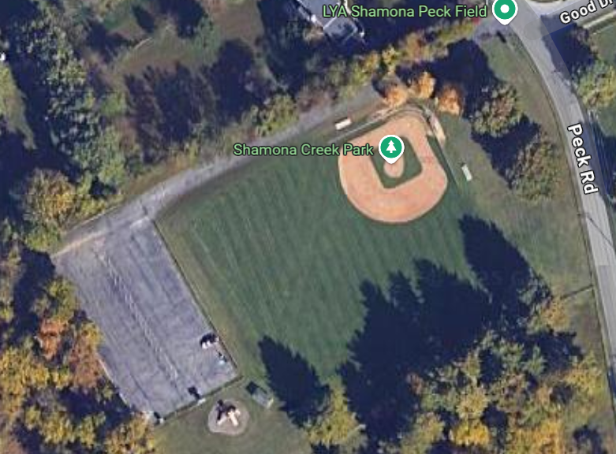
1 AED is located at Shamona Peck Field (year round) to the left of the driveway as you enter the park, near the park sign.

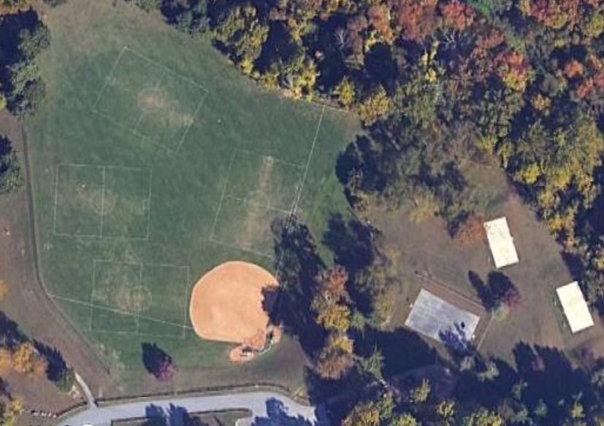
Shamona Main Fields

1 AED is located at Shamona Main Field (year round) to the top of the driveway as you enter the park, near the park sign.
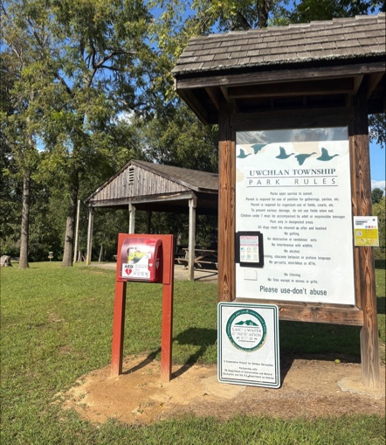

Spring Run Field
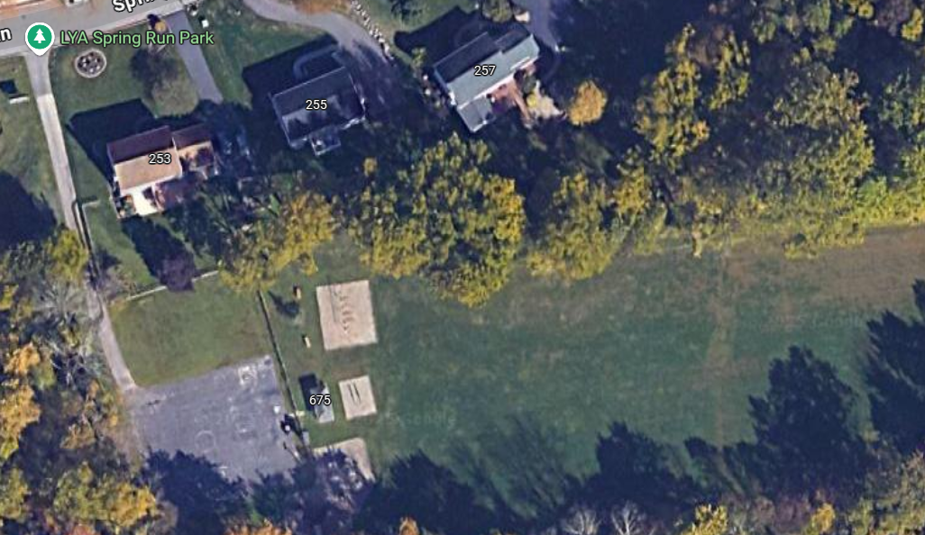
1 AED is located at Spring Run Field (only available March-November) near the park sign, facing the pavilion
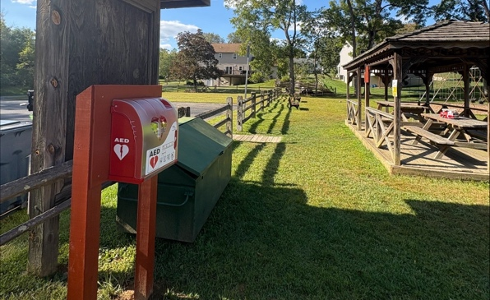

Martin’s Farm Field
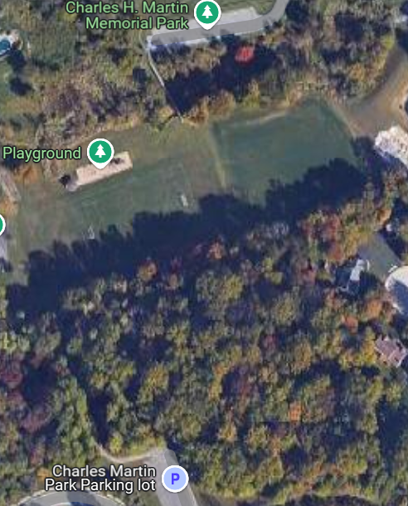

1 AED is located at Martin’s Farm Field (only available March-November) on the pavilion, facing the field.

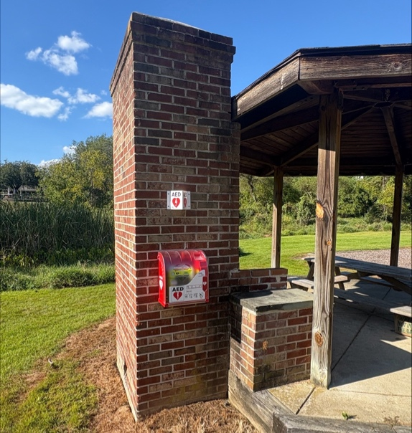

Williamsburg Field
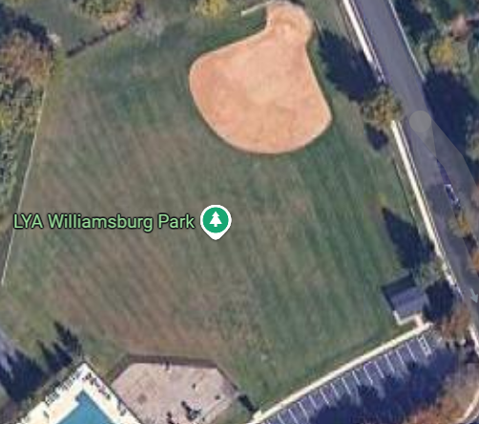
1 AED is located at Williamsburg Field (only available March-November) near the
pavilion.

Acker Park
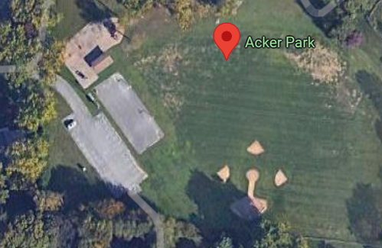
1 AED is located at Acker Field (only available March-November) near the park sign.
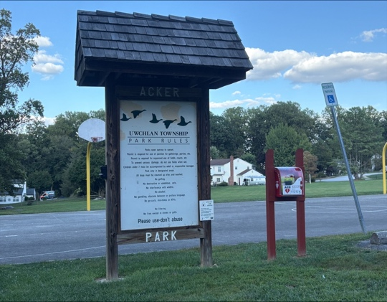

Eagleview Baseball/Softball
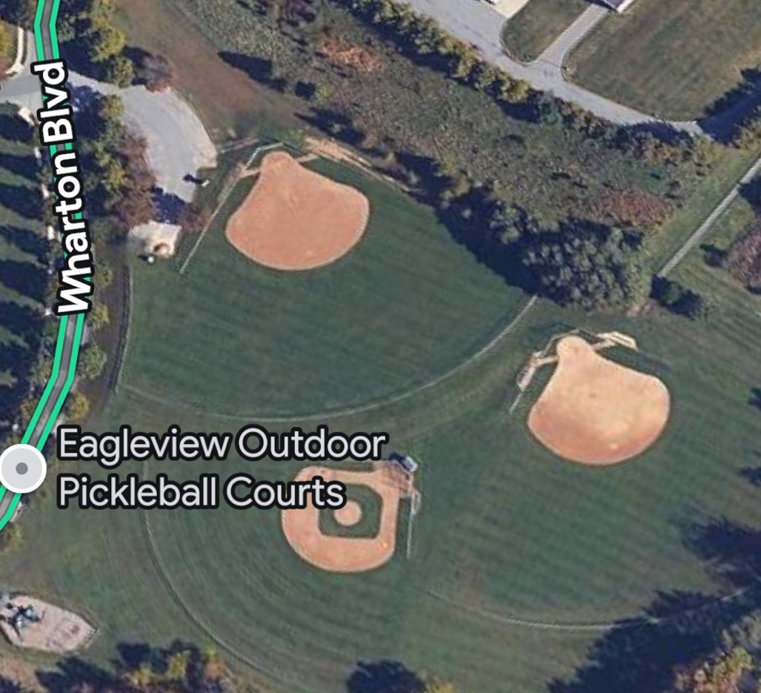
1 AED is located at Eagleview Baseball/Softball Fields (only available March-November) near the park sign in the parking lot.
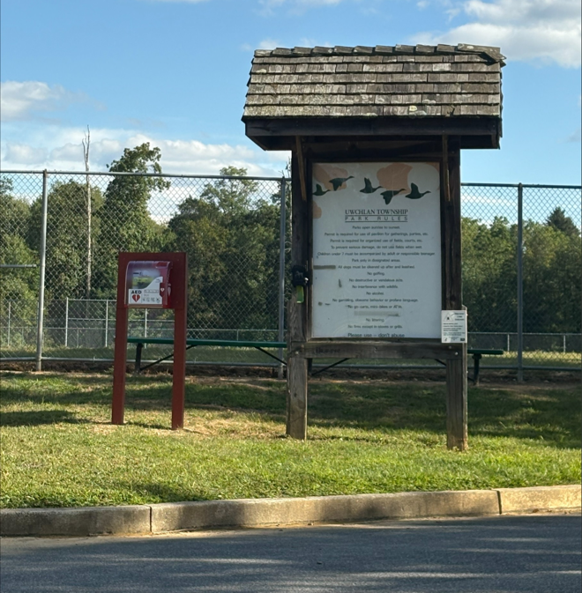

Eagleview Soccer
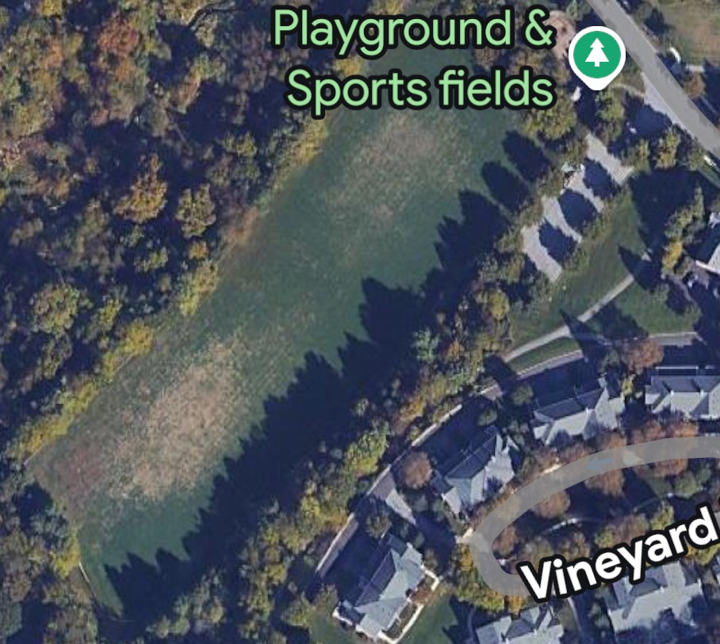
1 AED is located at Eagleview Soccer Fields (only available March-November) near the playground.
